
QUICK CONFIRMATION AGREEMENT

Name: | «CON1SAL» «CON1FIRST» «CON1LAST» | Hotel Name:
Title: | «CON1TITLE» | Sales Manager: | «SALESID»
Company Name: | «GROUPNAME»
Address: | «ADDR1» | Phone:
 | «ADDR2» | Fax:
City, State, Zip: | «CITY», «STATE» «ZIP»
 |  | Name of Event: | «BOOKNAME»
Phone: | «CON1PHONE» Ext: «CON1EXT»
Fax: | «CON1FAX»

We are pleased to offer the following accommodations for your event:
SLEEPING ROOMS and RATES

<<room table>>

TOTAL ROOM BLOCK RESERVED: «RMBLOCK»

Room rates are quoted exclusive of local taxes and fees, currently ____. Quoted rates will be offered, based on availability, to your attendees ___ days before and ___ days after the above dates.
FUNCTION SPACE and FOOD AND BEVERAGE

<<meeting table>>

The sleeping rooms, function space and food and beverage functions listed above will be considered definite commitments upon signing of this agreement by both parties, and will be subject to all terms and conditions set forth on the reverse side. Faxed signatures will be accepted. The persons signing below agree that they are authorized representatives of the above indicated group and hotel who have authority to enter this contract. This agreement and the terms and conditions on the reverse side may not be changed or amended unless done so in writing and signed by both parties.

Dated: __________ By: _______________________ For (enter Hotel): _________________________

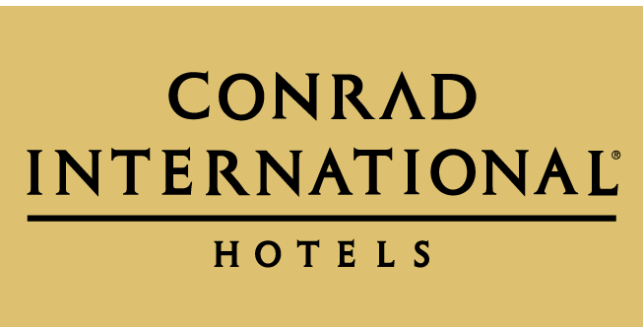
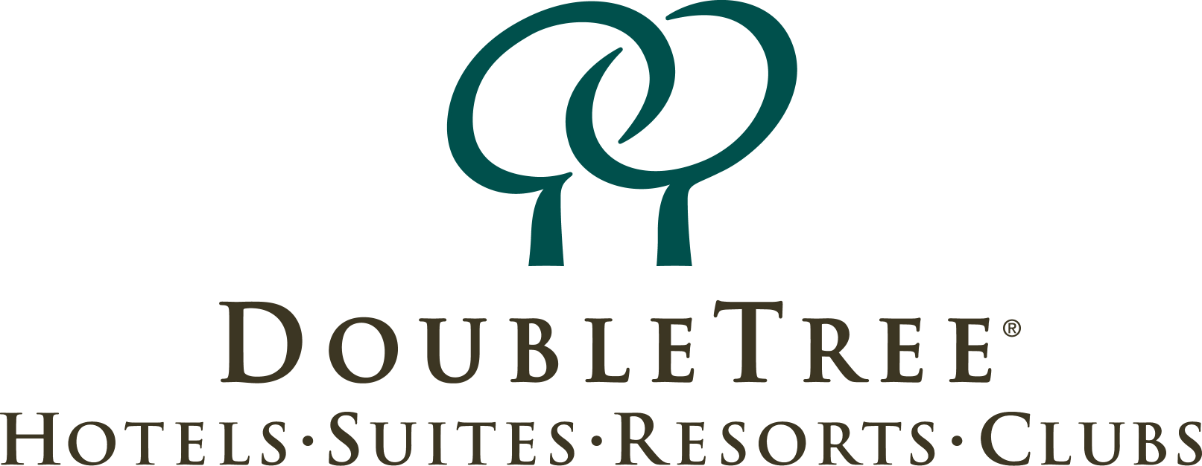
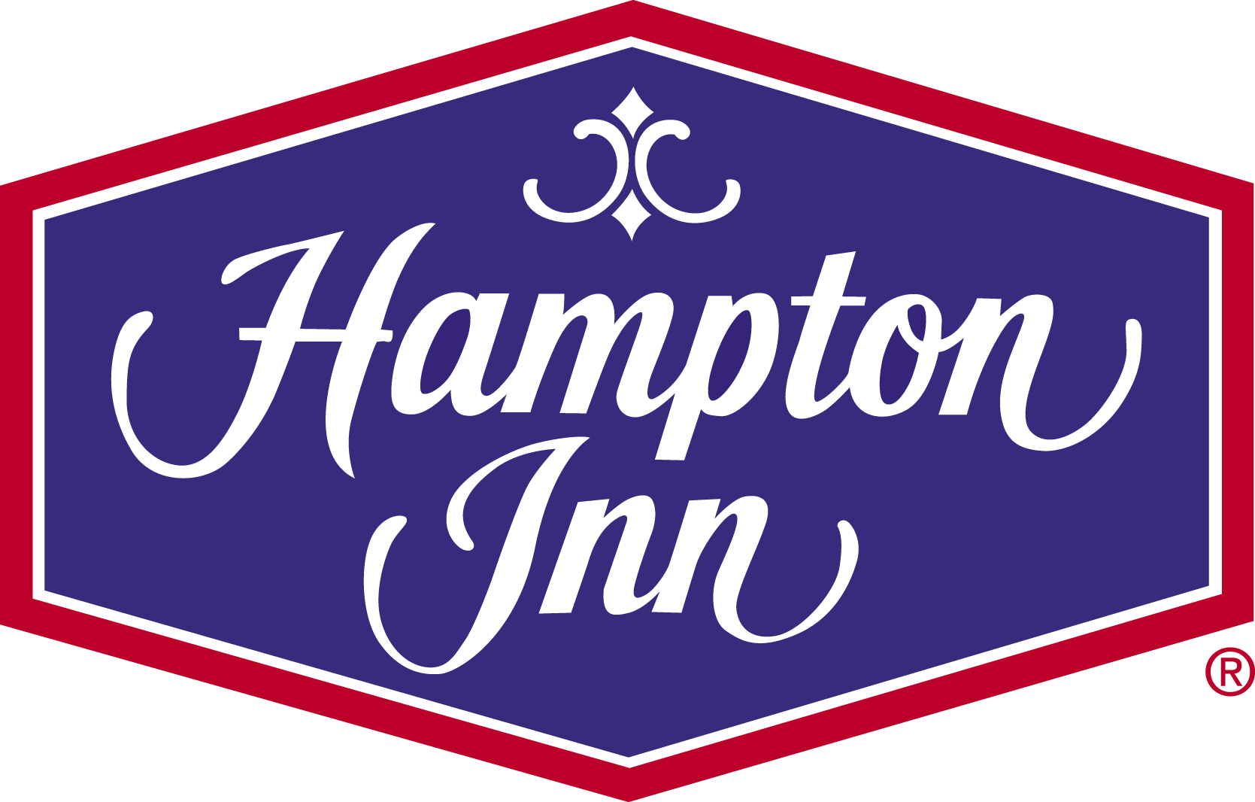
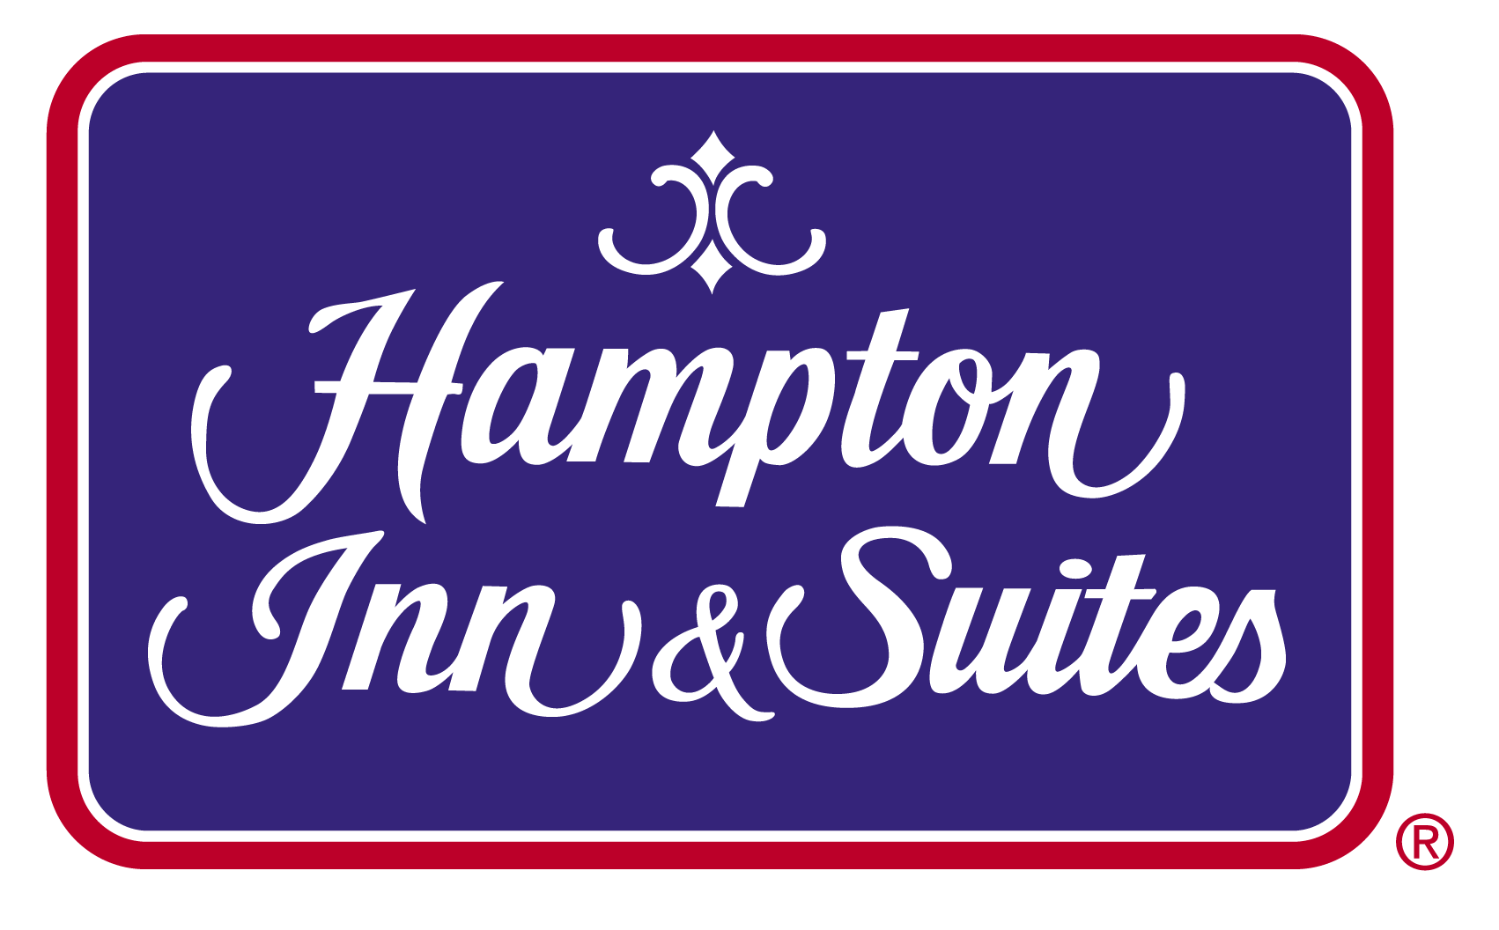
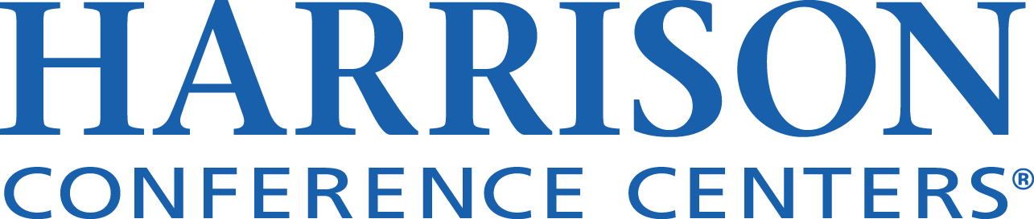
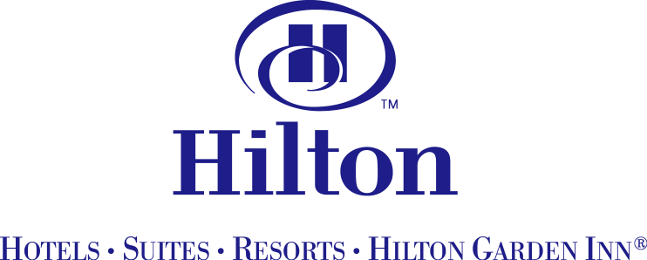
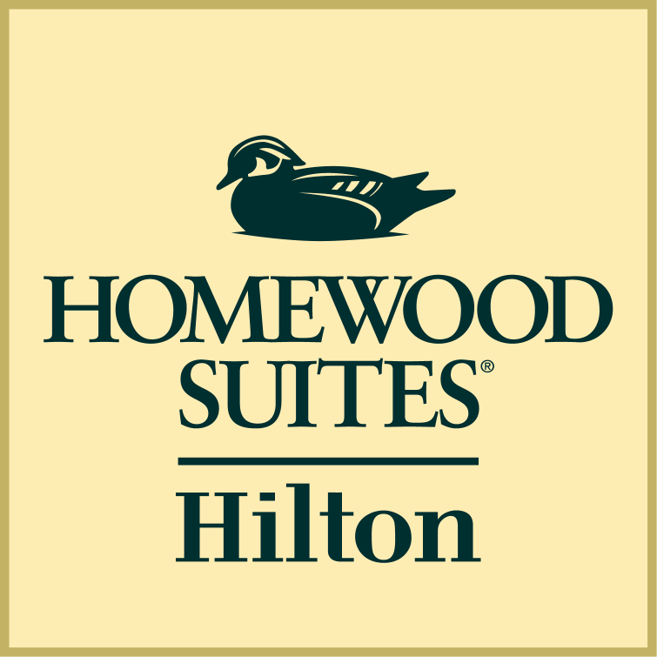
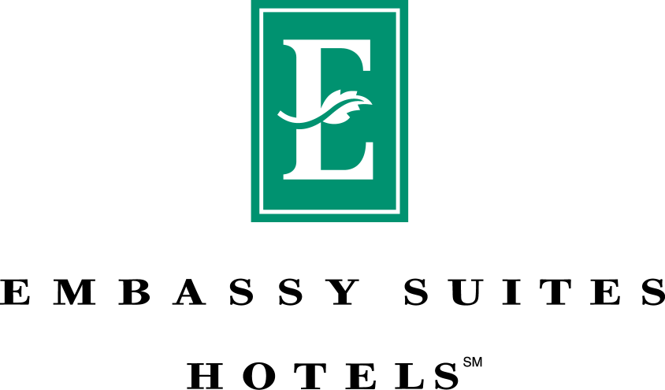

STANDARD TERMS AND CONDITIONS

RESERVATIONS: Reservations will be made by: «RESVMETH» no later than «CUTDATE»

After that date, you agree that we may offer unused rooms held in your block to other customers to reduce our losses and your obligations under the performance clause. Reservations requested by your attendees after this date will be accepted based upon availability.
- COMMISSION / THIRD PARTY PAYMENTS: The Hotel will pay ($ or % of minimum room rate) for each revenue room night actualized and paid for by your group to (group, name of company or whatever) for the purpose of (commission, bussing, defraying costs, etc). Any change in the recipient of this payment after the contract is signed will require written notification, signed by both you and the recipient. Payment will be made after receipt by the Hotel of full payment for the event. You will take full responsibility for determining whether disclosure of payments is required and for making disclosure of all such payments, and defend and indemnify Hotel in any claims arising out of or related to disclosure.

CANCELLATION AND PERFORMANCE: The rates offered by us are based in part upon the total gross revenue anticipated by us from your agreement to use and pay for the rooms and events listed on the opposite side. You agree and understand that in the event of a cancellation or lack of full performance by you, our actual damages would be difficult to determine. Therefore, you have agreed to pay reasonable liquidated damages to the Hotel for cancellation or lack of performance as described in this paragraph. Cancellation damages will be calculated as a percentage, based on the date of cancellation listed below, of total anticipated gross revenues from all contracted sleeping rooms, food and beverage and meeting room rental listed on the opposite side.

Date of Cancellation Percentage owed

Date of signing to 90 days in advance 10%

89 days to 60 days in advance 25%

59 to 30 days in advance 40%

29 days or less in advance of event 60%

If the event is held, but the Hotel does not realize the total revenue anticipated from your event, you agree to pay performance damages. The damages owed will be the amount necessary for the Hotel to receive no less than 80% of the total anticipated revenue from your event.

PAYMENT IN ADVANCE: Unless you have established credit in advance with us, you will pay the entire contract price in cash or by certified check at least three days prior to your function or by personal bank check two weeks prior to your function. If you have established credit, payment in full will be due within thirty (30) days of your function.

OUTSIDE FOOD AND BEVERAGE: Due to state law, you may not bring to the Hotel alcoholic beverages. You must obtain prior approval from us before you bring in any food or non-alcoholic beverages from outside sources.

SECURITY: We have no insurance for and are not responsible for any loss or damage to your property. If required, in our sole judgment, in order to maintain adequate security measures in light of the size and/or nature of your function, you will provide, at your expense, security personnel supplied by a reputable licensed guard or security agency doing business in the city or county in which we are located, which agency will be subject to our prior approval.

INDEMNIFICATION & INSURANCE: To the extent permitted by law, you agree to protect, indemnify, defend and hold harmless the Hotel, Hilton, and the owner of the Hotel, and their respective employees and agents against all claims, losses or damages to persons or property, governmental charges or fines, and costs (including reasonable attorney's fees), arising out of or connected with your function, except those claims arising out of the sole negligence or willful misconduct of the Hotel. You further agree to obtain and keep in force General Liability Insurance covering the event described in this contract with limits of not less than $1,000,000 per occurrence and to provide the Hotel with a certificate of insurance naming Hotel, Hilton and the owner as an additional insured for your event.

AUXILIARY AIDS: The Hotel represents and you acknowledge that the Hotel facilities being rented for you including guest rooms, common areas and transportation services will be in compliance with our public accommodation requirements under the Americans With Disabilities Act. You agree that one week in advance you will furnish to us a list of any auxiliary aids needed by your attendees in meeting or function space. You agree to pay all charges associated with the provision of such aids. When your attendees make room reservations, please ask them to notify us of their auxiliary aid needs so that we may notify you as to the names of businesses with which you may contract to obtain those aids.

PROMOTIONAL CONSIDERATIONS: We have the right to review and approve any advertisements or promotional materials in connection with your function that specifically reference any name or logo of the Hilton family of Hotel brands.

ARBITRATION: The parties agree that any dispute in any way arising out of or relating to this contract will be resolved pursuant to the law of the state where the Hotel is located, and through arbitration before JAMS/ENDISPUTE® or American Arbitration Association, with the prevailing party entitled to an award of its reasonable attorney fees. The parties further agree that in any arbitration proceeding they may conduct reasonable discovery pursuant to the Federal Rules of Civil Procedure, that the law of the state in which the Hotel is located will be the governing law, and any arbitration award will be enforceable in state or federal court.

Dated: ____________ By: ______________________ For (enter Hotel): ____________________

